Unit 2 – Lesson 3. Adapter Class in Image Gallery App
Aim:
How do we build an Image Gallery App?

Objectives: After the lesson, students will be able to:
- Obtain understanding of ImageView and @drawable folder
- Understand Gallery View and BaseAdapter class

CLASS PROCEDURE:

Do Now:
Open the Image Gallery app we worked on yesterday. Have you completed the adapter class? What is the purpose of the adapter class?

Class Discussion / Presentation:

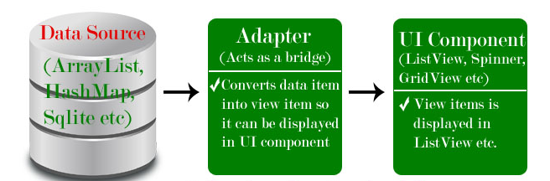

Lab / Pair – sharing Activity:
Work with your partner and complete the GalleryView app! Will be graded on Thursday as 10 points of HW credits.

References:

- In ActivityMain.java, declare an object Gallery, an Integer[] array to save the GalleryImageList R.id, and an object ImageView:

Gallery Imagegallery;
Integer[] GalleryImagesList =
{
R.drawable.one,
R.drawable.two,
R.drawable.three,
R.drawable.four,
R.drawable.five,
R.drawable.six,
R.drawable.seven
};
ImageView imgGalleryImage;

- We then need to instantiate the objects and link the objects to the UI in the onCreate(). To display a big image when the smaller image icon is clicked, we use a class ImageAdapter class that will be specified later. We need to instantiate it in the onCreate(). Here’s the onCreate() method:

protected void onCreate(Bundle savedInstanceState)
{
super.onCreate(savedInstanceState);
setContentView(R.layout.activity_main);
imgGalleryImage = (ImageView)findViewById(R.id.imgGalleryImage);
imgGalleryImage.setImageResource(R.drawable.one);
Imagegallery = (Gallery)findViewById(R.id.gallery);
Imagegallery.setAdapter(new ImageAdapter(this));
Imagegallery.setOnItemClickListener(new OnItemClickListener()
{
@Override
public void onItemClick(AdapterView<?> parent, View view,
int position, long id)
{
imgGalleryImage.setImageResource(GalleryImagesList[position]);
}
});
}
- Finally, we need to write the ImageAdapter class. The ImageAdapter class extends a BaseAdapter class provided by Android. The purpose is to allow the user to slide, pick a smaller image icon on the top and then display it as a big image on screen. We need to getCount() and getItem() and getItemId() before we return the View.

private class ImageAdapter extends BaseAdapter
{
Context context;
public ImageAdapter(Context context)
{
this.context = context;
}
@Override
public int getCount()
{
return GalleryImagesList.length;
}
@Override
public Object getItem(int position)
{
return GalleryImagesList[position];
}
@Override
public long getItemId(int position)
{
return position;
}
@Override
public View getView(int position, View convertView, ViewGroup parent)
{
ImageView imageView = new ImageView(this.context);
imageView.setImageResource(GalleryImagesList[position]);
imageView.setLayoutParams(new Gallery.LayoutParams(150, 200));
imageView.setScaleType(ScaleType.FIT_XY);
return imageView;
}}
- Don’t forget to set the Gallery and the ImageView in the activity_main.xml! Here’s an example of the finished app:

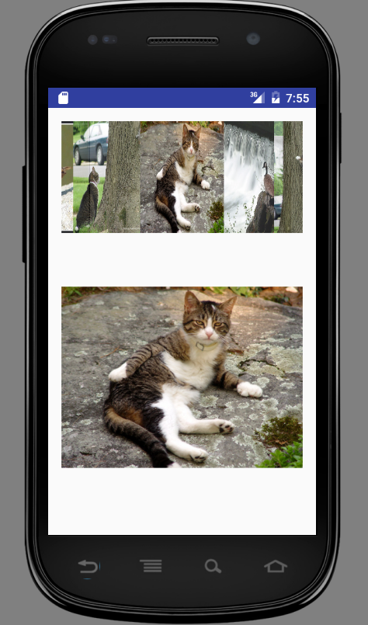

Sample Solution:

activity_main.xml:

<?xml version="1.0" encoding="utf-8"?>
<LinearLayout xmlns:android="http://schemas.android.com/apk/res/android"
xmlns:tools="http://schemas.android.com/tools"
android:layout_width="match_parent"
android:layout_height="match_parent"
android:paddingBottom="@dimen/activity_vertical_margin"
android:paddingLeft="@dimen/activity_horizontal_margin"
android:paddingRight="@dimen/activity_horizontal_margin"
android:paddingTop="@dimen/activity_vertical_margin"
tools:context="com.example.wendyqiu.galleryview.MainActivity"
android:orientation="vertical" >
<Gallery
android:id="@+id/gallery"
android:layout_width="fill_parent"
android:layout_height="wrap_content"/>
<ImageView
android:id="@+id/imgGalleryImage"
android:layout_width="fill_parent"
android:layout_height="fill_parent"/>
</LinearLayout>

MainActivyt.java:

package com.example.wendyqiu.galleryview;
import android.support.v7.app.AppCompatActivity;
import android.os.Bundle;
import android.app.Activity;
import android.content.Context;
import android.os.Bundle;
import android.view.View;
import android.view.ViewGroup;
import android.widget.AdapterView;
import android.widget.BaseAdapter;
import android.widget.Gallery;
import android.widget.ImageView;
import android.widget.AdapterView.OnItemClickListener;
import android.widget.ImageView.ScaleType;
public class MainActivity extends Activity {
@SuppressWarnings("deprecation")
Gallery Imagegallery;
Integer[] GalleryImagesList =
{
R.drawable.one,
R.drawable.two,
R.drawable.three,
R.drawable.four,
R.drawable.five,
R.drawable.six,
R.drawable.seven
};
ImageView imgGalleryImage;
@Override
protected void onCreate(Bundle savedInstanceState)
{
super.onCreate(savedInstanceState);
setContentView(R.layout.activity_main);
imgGalleryImage = (ImageView)findViewById(R.id.imgGalleryImage);
imgGalleryImage.setImageResource(R.drawable.one);
Imagegallery = (Gallery)findViewById(R.id.gallery);
Imagegallery.setAdapter(new ImageAdapter(this));
Imagegallery.setOnItemClickListener(new OnItemClickListener()
{
@Override
public void onItemClick(AdapterView<?> parent, View view,
int position, long id)
{
imgGalleryImage.setImageResource(GalleryImagesList[position]);
}
});
}
private class ImageAdapter extends BaseAdapter
{
Context context;
public ImageAdapter(Context context)
{
this.context = context;
}
@Override
public int getCount()
{
return GalleryImagesList.length;
}
@Override
public Object getItem(int position)
{
return GalleryImagesList[position];
}
@Override
public long getItemId(int position)
{
return position;
}
@Override
public View getView(int position, View convertView, ViewGroup parent)
{
ImageView imageView = new ImageView(this.context);
imageView.setImageResource(GalleryImagesList[position]);
imageView.setLayoutParams(new Gallery.LayoutParams(150, 200));
imageView.setScaleType(ScaleType.FIT_XY);
return imageView;
}
}
}

HW: Complete the Gallery app.

